SET 9 – Online Learning Activity Analysis Dataset
Student ID | Gender | Age | Course | Study Time (hrs) | Videos Watched | Quiz Score | Login Date
L01 | Male | 20 | R | 3.5 | 12 | 78 | 2025-01-05
L02 | Female | 22 | R | 4.2 | 15 | 85 | 2025-01-05
L03 | Male | 19 | SQL | 2.0 | 8 | 65 | 2025-02-08
L04 | Female | 21 | R | 5.0 | 18 | 92 | 2025-02-08
L05 | Male | 23 | R | 2.5 | 9 | 70 | 2025-03-12
L06 | Female | 20 | SQL | 4.0 | 14 | 88 | 2025-03-12

Q1. Histogram and Boxplot
Aim
To analyze the distribution of quiz scores and compare student performance across courses.
R Code
data <- read.csv("Online_Learning_Activity.csv")

data$Login_Date <- as.Date(data$Login_Date)

hist(data$Quiz_Score,
main = "Distribution of Quiz Scores",
xlab = "Quiz Score",
ylab = "Number of Students",
col = "skyblue")

boxplot(Quiz_Score ~ Course,
data = data,
main = "Quiz Score by Course",
xlab = "Course",
ylab = "Quiz Score",
col = "lightgreen")
Interpretation
- Quiz scores range from 65 to 92.
- Most students have scores between 65 and 92.
- R has more students in the dataset than SQL.
- The highest score is 92.
- The lowest score is 65.
- Overall, student performance is moderate to high.
Output:
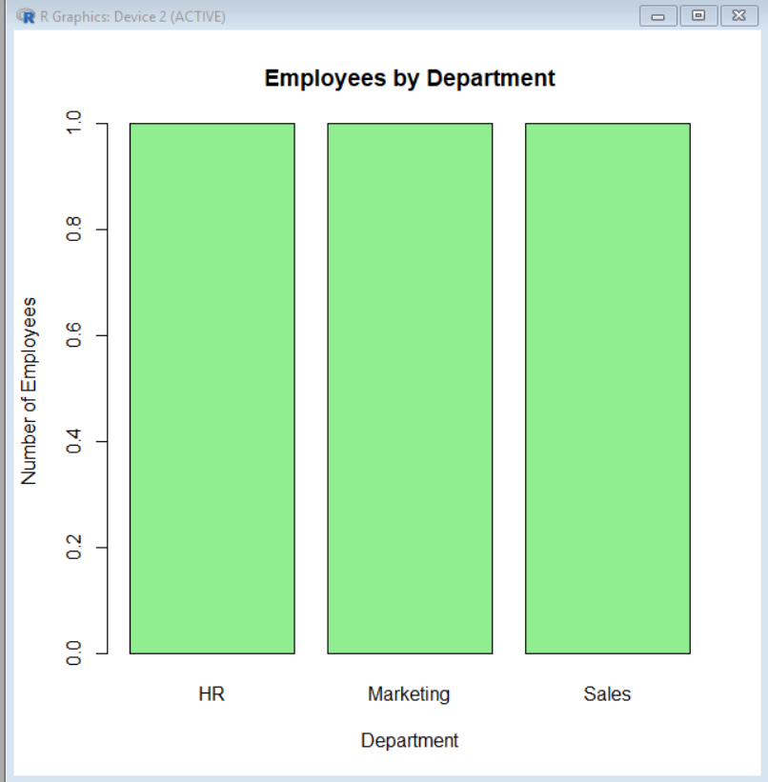

Q2. Scatter Plot – Study Time vs Quiz Score
Aim
To study the relationship between study time and quiz score while representing videos watched using bubble size.
R Code
plot(data$Study_Time,
data$Quiz_Score,
pch = 21,
bg = rgb(0, 0.5, 1, alpha = 0.5),
cex = data$Videos_Watched / 5,
main = "Study Time vs Quiz Score",
xlab = "Study Time (hours)",
ylab = "Quiz Score")
Explanation
- X-axis represents Study Time.
- Y-axis represents Quiz Score.
- Bubble size represents Videos Watched.
- Transparency helps overlapping points remain visible.
Learning Pattern
The plot shows a positive relationship between study time and quiz score. Students who spend more time studying generally tend to obtain higher quiz scores.
For example:
- 2.0 hours → 65
- 4.0 hours → 88
- 5.0 hours → 92
Conclusion:
Higher study time is generally associated with better quiz performance.
Output:
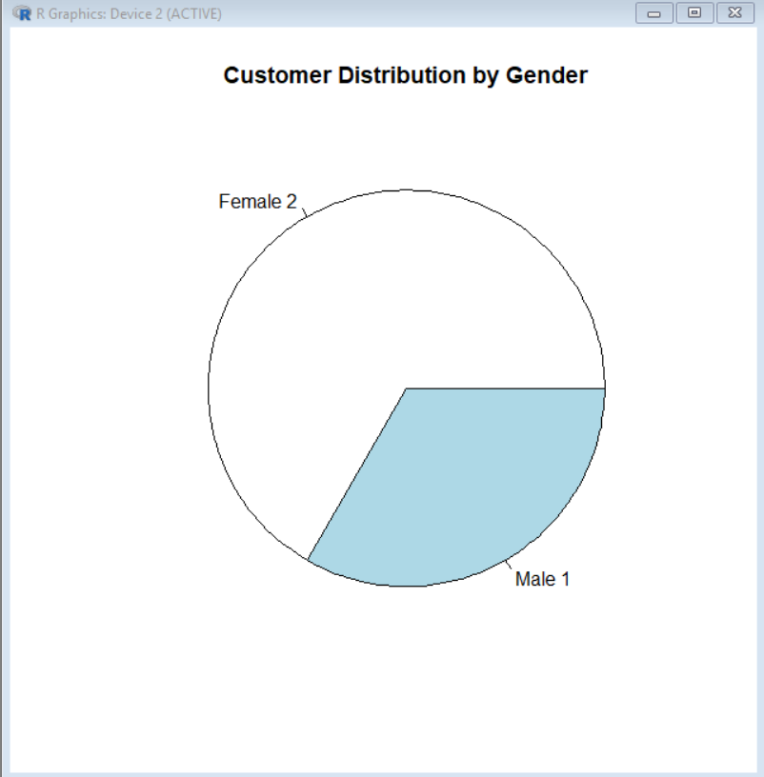

Q3. Monthly Average Quiz Score and Moving Average
Aim
To calculate the monthly average quiz score and visualize its trend using a line chart with moving average smoothing.
Step 1 – Convert Login Date
data$Login_Date <- as.Date(data$Login_Date)
Step 2 – Extract Month
data$Month <- format(data$Login_Date, "%Y-%m")
Step 3 – Calculate Monthly Average
monthly_avg <- aggregate(Quiz_Score ~ Month,
data = data,
FUN = mean)

print(monthly_avg)
The monthly averages are:
Month | Average Quiz Score
2025-01 | 81.5
2025-02 | 78.5
2025-03 | 79.0
Step 4 – Moving Average
monthly_avg$Moving_Average <- stats::filter(
monthly_avg$Quiz_Score,
rep(1/2, 2),
sides = 2
)
Step 5 – Line Chart
plot(monthly_avg$Quiz_Score,
type = "o",
xaxt = "n",
main = "Monthly Average Quiz Score",
xlab = "Month",
ylab = "Average Quiz Score")

axis(1,
at = 1:nrow(monthly_avg),
labels = monthly_avg$Month)

lines(monthly_avg$Moving_Average,
type = "o")
Interpretation
- January average = 81.5
- February average = 78.5
- March average = 79.0
- The score decreases from January to February.
- A small improvement occurs in March.
Trend:
The overall trend is relatively stable, with a slight decrease followed by a small recovery.
Output:
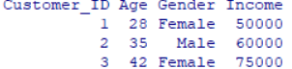

Q4. Tableau Mini Interactive Dashboard
Aim
To create an interactive dashboard for analyzing online learning activity.
Step 1 – Import Dataset
- Open Tableau.
- Select Text File.
- Select Online_Learning_Activity.csv.
- Check that the fields are correctly recognized.
Step 2 – Bar Chart: Average Quiz Score by Course
Columns: Course
Rows: Quiz Score
Aggregation: Average
Chart: Bar Chart
Title:
Average Quiz Score by Course

Step 3 – Scatter Plot
Columns: Study Time
Rows: Quiz Score
Add:
- Videos Watched → Size
- Gender → Color/Detail
Title:
Study Time vs Quiz Score

Step 4 – Add Filters
Add the following filters:
- Gender
- Course
This allows the user to view specific groups of students.

Step 5 – Create Dashboard
Add:
- Average Quiz Score by Course – Bar Chart
- Study Time vs Quiz Score – Scatter Plot
- Gender Filter
- Course Filter
Dashboard Title
Online Learning Activity Dashboard
Result
An interactive Tableau dashboard is created to analyze course performance, study time, quiz scores, gender, and video-watching activity.

